Cecil Armstrong Gibbs
Crossings Suite for Orchestra, Op. 20 (1919)

Similar to W S Lloyd Webber, Cecil Armstrong Gibbs lived to see his music go mainly out of fashion. It was sustained, particularly after his death in 1960, through amateur performances of such genres as his songs and part-songs in local music festivals, organists playing his Six Sketches (Books 1 and 2), and church choirs singing such pieces as Most Glorious Lord of Life.
Armstrong Gibbs has tended to be remembered as a composer of songs, primarily for his settings of the poems by Walter de la Mare. The musical world changed, trying (unnecessarily so) to keep in line with European ideas. Happily, like Robin Milford, the tide has now turned and Armstrong Gibbs is now being recognised as a primary figure within the ‘lesser-known British composers of the early twentieth century”.
Armstrong Gibbs first came to the attention of the musical public and establishment while teaching at The Wick School. In 1919 he was involved in arranging a celebration for retirement of the then headmaster, Lawrence Thring. The composer commissioned a children’s play from Walter de la Mare whose poetry he greatly admired and with whom he was slightly acquainted. Indeed, de la Mare had earlier approved of some early Gibb’s settings of his poems. Within a couple of months, de la Mare produced a play entitled Crossings and Gibbs duly set about writing the music. This magical play concerns four children who are left alone in a romantic mansion (‘Crossings’) to fend for themselves just before Christmas. It was subtitled ‘A Fairy Play’, in five scenes, and apart from the children, involves various grown-ups, fairies and a pedlar, as shown below:

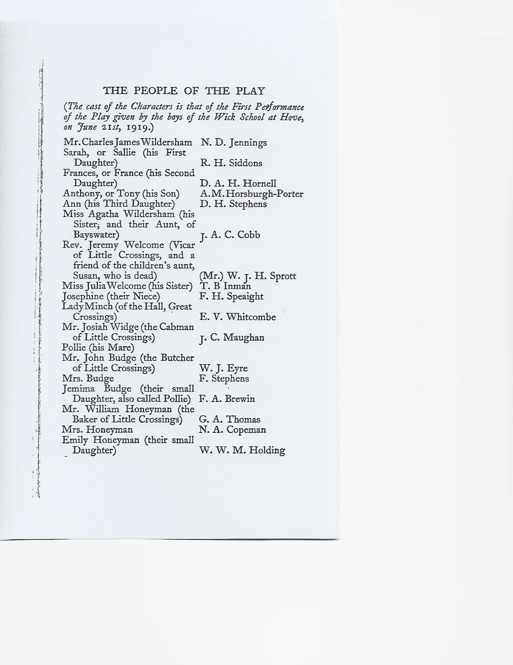

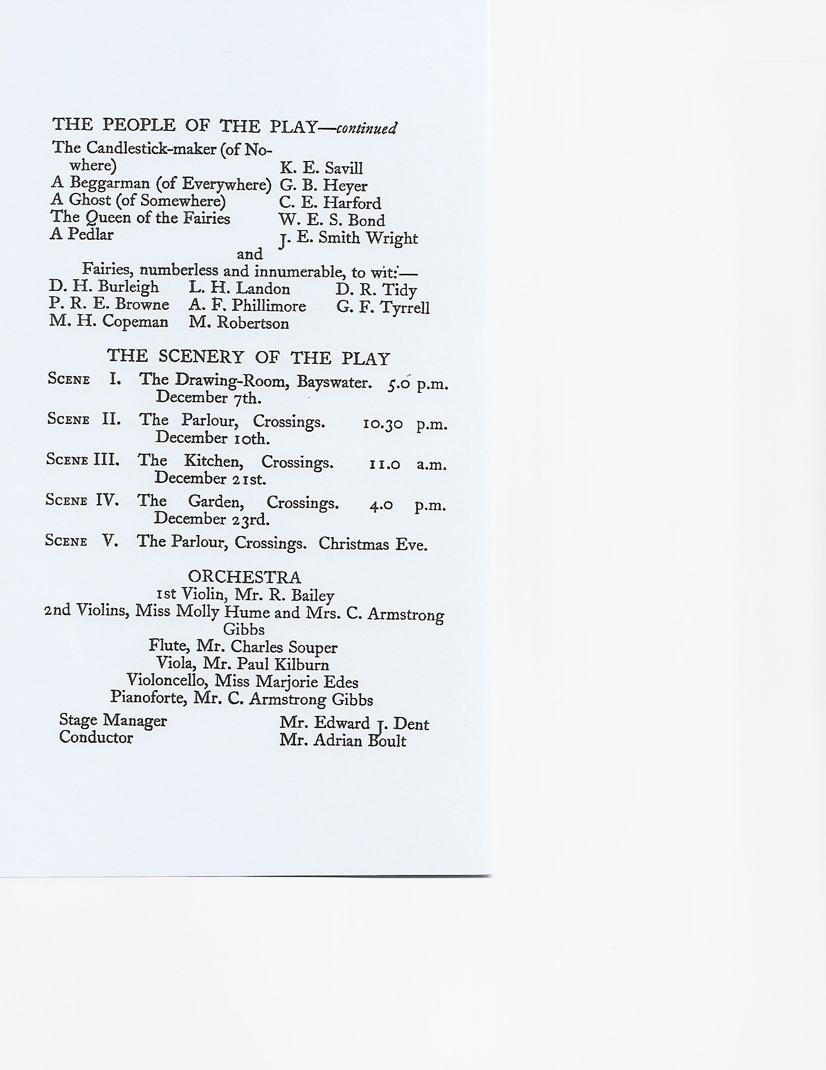

A young man named Ardian Boult conducted the work and was so impressed by Gibb’s music that he paid for the composer to study composition at the Royal College of music. The work was then performed, at a later date, in the Queen’s Hall.
Lewis Foreman writes, “Gibb’s music and its treatment surely reflects two notable children’s stage play of the time – Peter Pan and even more so Elgar’s Starlight Express, which had been seen in 1915”. However, Gibb’s melodies and rhythms, and use of solo instruments, are perhaps more daring, even looking forward to the score of Blake’s score of The Snowman.
A reflection on the work is shown below:
Construction | Main Musical Features | Descriptor (e.g. mystical, emotional, whimsical, programmatic element)
Setting (Introduction)  1. | Overture  Lively rhythms, main stately string theme (used throughout the work) with syncopated chordal accompaniment. | Anticipation of Edwardian-styled incidental music, as with Elgar’s Starlight Express, and the emotional ‘security’ which this brings.
Action (Main Section)  2, 3, 4 | The Arrival  Lento e dolce string writing, gentle melodic contours, harmony and rhythms; flute melody (sequential and repeating) with climax; harp appegiation.  Butcher, Baker and Candlestick Maker  Allegro risulto strong main theme, as above; more gentle clarinet theme, trumpet theme; return of main theme.  Scherzo: The Snow Tea  Vivace e leggeriero woodwind theme with pizzicato string accompaniment; decorative flute figuration; crescendo/ diminuendo contrasting material. | Depiction of the children arriving at the stately house, alone, for Christmas; the suggestion of fairy music.  Arrival of the individual characters; dancing.  The tea-party with action.
Conclusion (Coda, Codetta)  5 | Christmas Eve  Allegro con moto dance-like theme in duple compound/triple time; trumpet theme looking to the future; pizzicato strings; return to the main opening theme + ‘The First Nowell’ reference; crescendo with timpani; main theme in rhythmic augmentation; bell-like figuration in pizzicato strings. | Programme conclusion of happiness in Anne’s arrival.

In short, this work employs such features as fragmentary melodic and rhythmic phrases which point to a more ‘progressive’ form of English writing, in addition to one fine and Romantic theme created through gentle contours, all amidst gentle tonality with modulations.

© Peter Hunter, 2021

Cecil Armstrong Gibbs CD, Dutton Epoch, 2016

